**MAJOR-1 PROJECT**

**Documentation**

For

**Chatbot Based on AI**

Submitted By

|  |  |  |
| --- | --- | --- |
| **Specialization** | **SAP ID** | **Name** |
| AIML | 500096249 | Aryan Mankotia |
| AIML | 500096806 | Shubham Mehta |
| AIML | 500096748 | Priyanshu Gupta |



AI Cluster

School of Computer Science

University of Petroleum & Energy Studies

Dehradun - 248007. Uttarakhand

**Project Guide Cluster Head**

**Index**

|  |  |  |
| --- | --- | --- |
| **S. No.** | **Title** | **Page No.** |
|  | **Abstract** | **3** |
| **1** | **Introduction** | **3** |
| **2** | **Literature Review** | **4** |
| **3** | **Problem Statement** | **4** |
| **4** | **Objective** | **5** |
| **5** | **Methodology** | **6** |
| **6** | **Results** | **8** |
| **7** | **Future Scope** | **9** |
| **8** | **Conclusion** | **9** |

**Synopsis Report**

**Project Title**

Chatbot Based On AD

**Abstract**

This project develops an advanced chatbot system for Alzheimer's disease prediction, using convolutional neural networks (CNN) to analyze brain MRI images. The chatbot incorporates image-based predictions for early detection, as well as natural language processing (NLP) to engage with users through text-based interaction. Additional features include Wikipedia integration for contextual information and sound-based interaction via speech recognition, offering cognitive assessments through auditory inputs. The user interface is designed to be intuitive, providing an accessible platform for uploading images, conversing with the chatbot, and receiving diagnostic feedback. This multi-modal system combines image, text, and sound for a comprehensive Alzheimer’s prediction and support tool.

**1. Introduction**

Chatbots have become indispensable tools in recent times for improving user interaction in a variety of industries, such as customer service, education, and healthcare. Intelligent conversational bots are in high demand as companies look for ways to increase productivity and user happiness. Users become frustrated with traditional rule-based chatbots because they frequently are unable to provide meaningful and context-aware interactions.  
The Alzheimer's Disease Support Chatbot is designed to assist caregivers and patients in managing the challenges associated with Alzheimer's. This AI-driven system provides timely information, emotional support, and personalized care guidance, enhancing the quality of life for both patients and caregivers. By using natural language processing (NLP) and machine learning, the chatbot can offer practical advice on daily activities, symptoms, and coping strategies while fostering engagement and reducing feelings of isolation. It aims to be a reliable companion, promoting patient safety and caregiver well-being through accessible, compassionate, and continuous support.

Convolutional Neural Networks (CNNs) are used in Alzheimer's disease research for analyzing brain imaging data, such as MRI and PET scans. By automatically detecting patterns and abnormalities, CNNs help in early diagnosis and progression prediction, improving the accuracy of identifying Alzheimer's-related brain changes and aiding in timely intervention and treatment.

The Wikipedia Library enhances chatbot systems by integrating its extensive and reliable knowledge base, enabling chatbots to provide accurate and detailed responses. This integration improves the chatbot's ability to handle a wide range of inquiries with well-informed answers. For sound systems, text-to-speech technology can be used to vocalize the content, making information accessible audibly. The interface design benefits from seamless integration, allowing users to query directly through the chatbot and receive structured, relevant responses. This combination enriches the user experience, making interactions more informative and engaging.

**2. Literature Review**

The authors in [1] proposed an innovative AI-driven solution: employing an LLM based chatbot as an alternative to human interviewers in dementia intervention programs. LLMs or Large Language Models are state-of the-art Machine Learning models that can conduct open conversations like humans. Compared to human counterparts, LLM-based chatbots are accessible round-the-clock at lower costs. The chatbot was specifically designed to offer cognitively demanding conversations, mimicking the human-interviewer-based previous, and providing patient-friendly interfaces to effectively engage with older adults Furthermore, it ensured natural, effortless conversations through a soothing vocal interface, thereby accommodating older adults with varying cognitive capacities.

The authors in [2] implemented and trained 4 models including Long Short-Term Memory (LSTM), Gated Recurrent Unit (GRU), Bidirectional LSTM, and Dense Neural Network on preprocessed dataset of first aid. Performance evaluation metrics such as accuracy, precision, recall, and user feedback were employed to assess the efficacy of the developed chatbot. The development process involved several key phases. Initially, a dataset comprising first aid intents is collected and meticulously preprocessed using NLTK's tokenization, part-of-speech tagging, and syntactic parsing functionalities to extract meaningful information from user inputs. The DNN was best performing.

In [3] the authors have distinguished between two classes: mild-demented and non-demented. CNN was used because its able to handle enormous datasets and achieve good classification performance. The authors proposed two architectures for the study: A pretrained VGG 16 and a CNN model built from scratch. The data was augmented by six operations: rotation at 15 degrees, width shift with a range of 0.1, height shift with a range of 0.1, shearing with a range of 0.2, zooming with a range of 0.2, and applying horizontal flip CNN gave better accuracy than VGG 16.

In [4] the authors provide a comprehensive survey on the evolution and deployment of LLM-based AI chatbots, particularly highlighting their impact since the advent of OpenAI's ChatGPT. It covered the development of foundational chatbots, the progression of large language models (LLMs), and their applications across various sectors including education, healthcare, software engineering, and finance. The study emphasizes the potential of these chatbots in providing medical guidance, software development support, and other industry-specific solutions, showcasing their efficiency and scalability.

In [5] the authors proposed Artificial Neural Networks (ANNs) are powerful for capturing complex, non-linear patterns using ReLU activation in hidden layers and Softmax for multi-class classification. Logistic regression was simpler but assumes linearity, making it less effective for complex data. Decision trees handle non-linearity but tend to overfit, while random forests reduce overfitting by aggregating multiple trees. Support Vector Machines (SVMs) excel in high-dimensional spaces but are computationally intensive. Each model offers different strengths based on task complexity and computational needs.

In [6] the authors provided an approach which divided chatbot development into information abstraction and response design. Information abstraction involves gathering data, applying Natural Language Processing (NLP), and using machine learning algorithms like classification techniques to structure and organize queries. Data manipulation stores and optimizes this information for future interactions, using tags and database management systems like MySQL or MongoDB. Response design leverages tools like Dialogflow to configure intents, contexts, and entities, enhancing dialogue flow and user experience. Finally, entity recognition and custom objectives improve chatbot accuracy by better understanding and grouping user interactions.

In [7] The authors discussed the development of a novel medical chatbot designed to diagnose Alzheimer's disease using a Deep Neural Network (DNN). The chatbot allowed users to interact with an AI system to analyze symptoms and MRI scan reports, providing a more accessible and timely diagnosis compared to traditional methods. The system aimed to reduce the need for frequent hospital visits, especially for working individuals. The chatbot leverages machine learning techniques, including TensorFlow and Keras, to process data and improve prediction accuracy. The research highlighted the chatbot's potential to function as a virtual doctor, offering diagnostic support and analyzing disease severity, symptoms, risk factors, and prevention methods.

The authors in [8] implemented a structured prototype methodology, the chatbot was designed to improve information retrieval and provide personalized article recommendations. User Acceptance Testing (UAT) yielded a high satisfaction score of 4.14, indicating positive user experiences. The chatbot's integration with the OpenAI API significantly improved information extraction and user satisfaction.

The authors in [9] implemented ChatterBot library and hosted on the web using the Flask framework. The chatbot begins by collecting the user's name, primary ailment, and duration of symptoms, followed by more detailed symptom inquiries. The responses are processed and stored in a database, and the chatbot provides answers based on the highest accurate match from the database. The paper emphasizes the chatbot's ability to offer quick and accurate responses, making healthcare more accessible, especially for those who cannot afford frequent doctor visits.

In [10] the authors outlined the evolution of digital healthcare, from the digitization of patient records to the use of mobile apps and wearable devices for health monitoring. It also emphasizes the potential benefits of LLMs in improving medical processes, providing evidence-based treatment options, and enhancing patient access to medical information.

In [11] the authors discussed the importance of thoroughly testing, verifying, and validating chatbots to prevent failures, especially when faced with ambiguous or illegible inputs. It emphasized on algorithm testing as a promising solution, exploring techniques like cross-validation, grammar and parsing verification, and statistical parsing. The paper details the use of Naive Bayes and Support Vector Machines (SVMs) for text classification and intent identification, highlighting their testing methods and performance metrics. The goal was to enhance chatbot reliability and make interactions indistinguishable from human conversations.

In [12] the difference between the brain of patients and brain of normal persons is shown. In AD the shrinkage of cerebral cortex happens along with shrinkage of hippocampus and enlarged ventricles in between.

In [13] the authors used the Cornell Movie Dialog Corpus, containing over 220,000 conversation exchanges from 617 films to develop a chatbot based on the BiLSTM model. This chatbot processed user inputs to generate movie-related dialogue responses by leveraging bidirectional LSTM’s ability to capture both past and future context. The chatbot's architecture included sequence-to-sequence translation methods, and its output is evaluated based on the accuracy of its responses. Embeddings and feature-based models helped manage sparse data by extracting word characteristics, improving the chatbot's performance. Evaluation ensured the chatbot’s generated responses align with user inputs effectively.

**3. Problem Statement**

Alzheimer's disease presents major challenges for loved ones as well as patients because of its progressive nature and extensive management requirements. Current Alzheimer's patient support systems do not provide real-time, interactive, or personalized assistance. This gap can result in insufficient symptom management, higher stress levels for caregivers and a lower quality of life. A chatbot created expressly for Alzheimer's disease could help bridge this gap by providing timely information, emotional support, and practical advice. The lack of such a specialized tool emphasizes the need for novel solutions to improve patient and caregiver experiences when managing Alzheimer's disease.  
**4. Objectives**

The objective of this project is to develop a chatbot tailored to Alzheimer’s disease that provides personalized support and information to patients and caregivers. The chatbot will aim to enhance patient well-being by delivering real-time assistance, tracking symptoms, offering cognitive exercises, and providing resources for managing daily activities. Additionally, it will support caregivers by offering stress-relief strategies, caregiving tips, and connecting them with relevant support networks. By integrating AI and natural language processing, the chatbot will improve the quality of care and support for individuals affected by Alzheimer’s disease

**5. Methodology**

* 1. **Image Data Collection:**
  + Obtain Alzheimer's disease image datasets from reliable sources, ensuring a mix of modalities (MRI, CT scans).
  + Normalize and resize images, then split into training, validation, and test sets.

**5.2. Model Development:**

* + **Model Selection:** Choose best CNN architectures

These steps have been completed for 4 stages of Alzheimer's disease across the mentioned CNN models.

**5.3. Chatbot Development**

**5.3.1. NLP based Chatbot Creation**

1. **Requirement Analysis:**

* Define the scope and functionalities of the chatbot (e.g., symptom checker, general information on Alzheimer’s).

1. **Dataset for Chatbot Training:**

* Collect and curate a dataset of common questions and responses related to Alzheimer’s disease.
* Include varied user intents and contextual responses.

1. **Text-based Response Generation**:

* Preprocess user query, vectorize using TF-IDF, and compute cosine similarity to select the most relevant response.
* Display the relevance scores too.

1. **User Interaction Design:**

* Design and implement the chatbot interface for user interaction using PyQt5.
* Ensure the interface is intuitive and user-friendly.

**5.3.2. Enhancing Chatbot Features**

1. **Sound Features:**

* Integrate text-to-speech (TTS) functionality for voice responses.
* Add sound effects to enhance user engagement and experience.

1. **Visual Interface:**

* Develop a graphical user interface (GUI) with options for text and image inputs.
* Include visual elements like buttons, images, and interactive components for a richer user experience.
* **Image Analysis**: Preprocess the MRI image, extract features using a CNN, generate a caption describing the brain scan, and predict the stage of Alzheimer's.
  1. **Testing and Validation: -**

1. **System Testing:**

* Conduct comprehensive testing to ensure the chatbot functions correctly and integrates seamlessly with the CNN model.
* Perform usability testing to identify and address user experience issues.

1. **Feedback Collection:**

* Gather feedback from users to identify areas for improvement.
* Iteratively refine the chatbot based on user feedback and performance metrics.
  1. **Deployment and Maintenance: -**

1. **Deployment:**

* Deploy the chatbot on relevant platforms (e.g., web, mobile applications).
* Ensure it is accessible to target users and performs reliably in real-world scenarios.

1. **Maintenance:**
   * + - Regularly update the chatbot to accommodate new information and improvements.
       - Monitor performance and address any issues or bugs that arise.

**6) Results:**

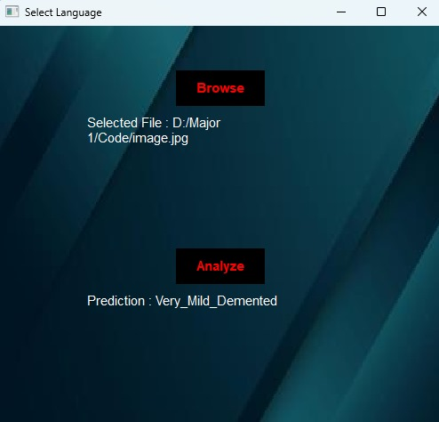

**Fig 6.1 Shows output/ caption for MRI image analysis**

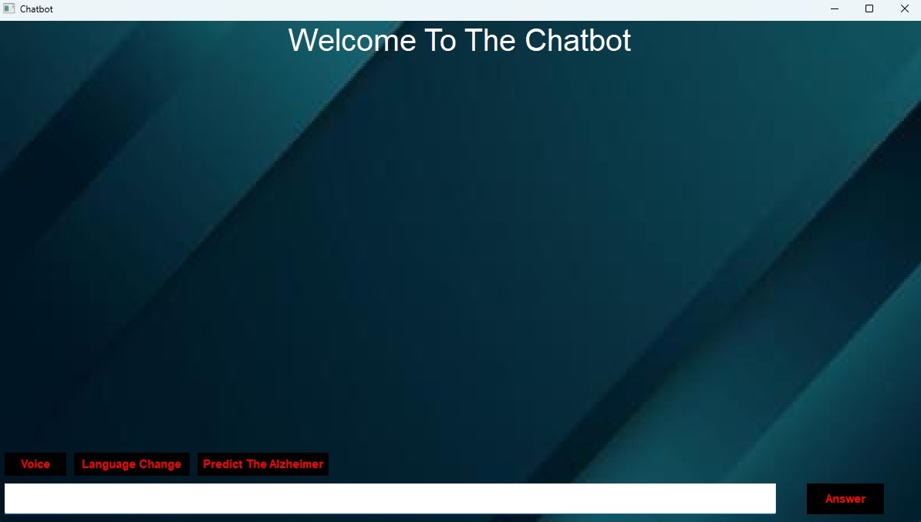

**Fig 6.2 Shows The Home Screen Of Interface**

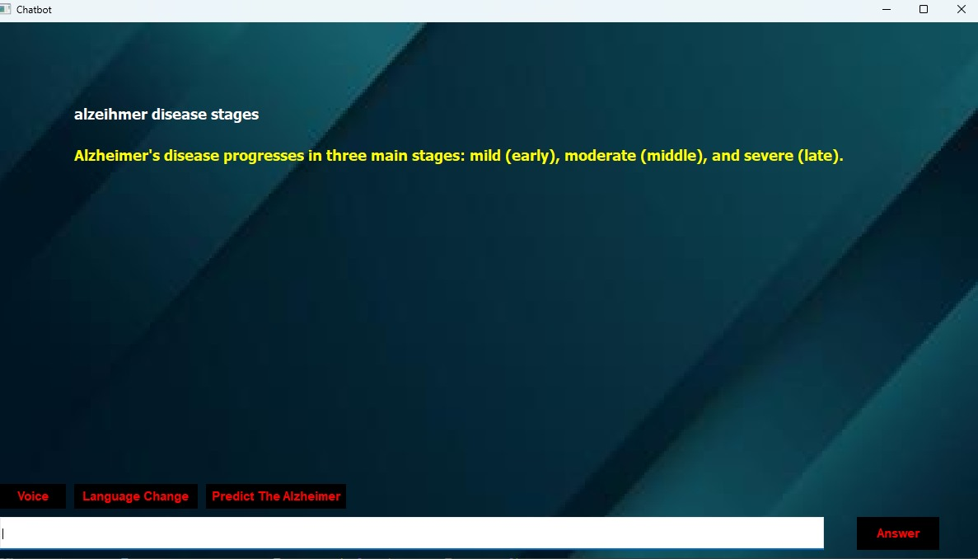

**Fig 6.3 Shows answer to a textual query entered by the user.**

**7) Future Scope**

The future scope of this project is broad, and includes improving the system’s accuracy, expanding and updating dataset regularly making it more interactive and accessible, integrating it into healthcare workflows, enhancing user engagement, and expanding its reach to broader use cases, including monitoring other neurological diseases. These improvements would allow the system to have a larger impact, helping both patients and healthcare providers in the early detection, diagnosis, and management of Alzheimer’s disease and related conditions.

**8) Conclusion**

The integration of advanced deep learning models for image analysis, natural language understanding using more sophisticated NLP models, and additional features like voice interaction and multilingual support enhanced the chatbot's capabilities. Moreover, integrating the system into real-world healthcare workflows through EHR integration and clinical validation will be crucial for its wider adoption in clinical settings.

In conclusion, this project serves as a foundation for a powerful tool that could improve the early detection, management, and overall care of individuals affected by Alzheimer's disease. It bridges the gap between artificial intelligence and healthcare, offering a scalable solution that could transform the way Alzheimer's is understood and managed in both clinical and home environments. With ongoing improvements and further research, this system could become a key player in the global effort to fight Alzheimer’s and similar neurodegenerative diseases.

**References**

[1] Hong, J., Zheng, W., Meng, H., Liang, S., Chen, A., Dodge, H. H., ... & Wang, Z. A-CONECT: Designing AI-based Conversational Chatbot for Early Dementia Intervention. In ICLR 2024 Workshop on Large Language Model (LLM) Agents.

[2] Kumar, T. R., Akarapu, A., Allam, S. R., Gattepally, N. C., & yashaswi Nellutla, P. (2024). CHATBOT APPLICATION USING NLTK AND KERAS.

[3] Arafa, D. A., Moustafa, H. E. D., Ali, H. A., Ali-Eldin, A. M., & Saraya, S. F. (2024). A deep learning framework for early diagnosis of Alzheimer’s disease on MRI images. Multimedia Tools and Applications, 83(2), 3767-3799.

[4] Dam, S. K., Hong, C. S., Qiao, Y., & Zhang, C. (2024). A complete survey on llm-based ai chatbots. *arXiv preprint arXiv:2406.16937*.

[5] M. Jain, P. Nathe, K. Rathod, N. K. Tiwari, S. Dedgaonkar and C. Shewale, "AI HealthCare Chatbot," 2024 MIT Art, Design and Technology School of Computing International Conference (MITADTSoCiCon), Pune, India, 2024, pp. 1-6, doi: 10.1109/MITADTSoCiCon60330.2024.10575622. keywords: Ethics;Data privacy;Medical services;Artificial neural networks;Chatbots;Data models;Security;Chatbot;Machine Learning;Deep Learning;Artificial Intelligence;HealthCare;Artificial Neural Networks

[6] P. Tanwar, K. Bansal, A. Sharma and N. Dagar, "AI Based Chatbot for Healthcare using Machine Learning," 2023 International Conference on Advances in Computation, Communication and Information Technology (ICAICCIT), Faridabad, India, 2023, pp. 751-755, doi: 10.1109/ICAICCIT60255.2023.10465728. keywords: {Industries;Automation;Natural languages;Medical services;Machine learning;Oral communication;Chatbots;Machine Learning (ML);Artificial Intelligence (AI);Chatbot;Natural Language Processing (NLP) Dialogflow},

[7] P, M., V, A.D., D, B., & S, M. (2023). A Novel Medical Chatbot with Alzheimer’s Disease Detection Using Deep Neural Network. *Computational Intelligence and Machine Learning*.

[8] Santoso, G., Setiawan, J., & Sulaiman, A. (2023). Development of OpenAI API Based Chatbot to Improve User Interaction on the JBMS Website. *G-Tech: Jurnal Teknologi Terapan*, *7*(4), 1606-1615.

[9] Goel, A., & Sharma, S. (2023, June). Artificial Intelligence based Healthcare Chat Bot System. In 2023 8th International Conference on Communication and Electronics Systems (ICCES) (pp. 1362-1366). IEEE.

[10] Park, S. G., Kim, A., Yoon, T., Kamyod, C., & Kim, C. G. (2023, November). A Study of Generative Large Language Model for Healthcare. In *2023 7th International Conference on Information Technology (InCIT)* (pp. 397-400). IEEE.

[11] Vijayaraghavan, V., & Cooper, J. B. (2020). Algorithm inspection for chatbot performance evaluation. *Procedia Computer Science*, *171*, 2267-2274.

[12] Breijyeh, Z., & Karaman, R. (2020). Comprehensive review on Alzheimer’s disease: causes and treatment. Molecules, 25(24), 5789.

[13] P. Anki, A. Bustamam, H. S. Al-Ash and D. Sarwinda, "High Accuracy Conversational AI Chatbot Using Deep Recurrent Neural Networks Based on BiLSTM Model," 2020 3rd International Conference on Information and Communications Technology (ICOIACT), Yogyakarta, Indonesia, 2020, pp. 382-387, doi: 10.1109/ICOIACT50329.2020.9332074. keywords: {Recurrent neural networks;Impedance matching;Chatbot;Data processing;Data models;Information and communication technology;Python;chatbot;program;BiLSTM;accuracy;input;output},